COEN 166 Artificial Intelligence

Homework #2

Guideline: Please complete the following problems and submit the answers as a single PDF file to Camino.

If the homework is hand-written and scanned, please make sure the handwriting is discernable, otherwise

credits may be deducted.

**Problem 1:** In the following table, select the correct definition/description of each term. The first one is done for you as an example.

| **A** | State Space | A | All states reachable from the initial state by a sequence of actions |
| --- | --- | --- | --- |
| **G** | Search Node | B | Guaranteed to find a solution if one is accessible |
| **J** | Link between nodes | C | Maximum number of successors of any node |
| **H** | Path | D | Set of all leaf nodes available for expansion at any given time |
| **F** | Optimal Search | E | Estimates cost of cheapest path from current state to goal state |
| **B** | Complete Search | F | Guaranteed to find lowest cost among all accessible solutions |
| I | Expand a state | G | Represents a state in the state space |
| **D** | Frontier | H | Sequence of states connected by a sequence of actions |
| K | Search Strategy | I | Apply each legal action to a state, generating a new set of states |
| **C** | Branching Factor | J | Represents an action in the state space |
| **E** | Heuristic Function | K | How a search algorithm chooses which node to expand next |

**Problem 2:** Consider a state space where the start state is number 1 and the successor function for state n returns two states, numbers 2n and 2n + 1.

(a). Draw the portion of the state space for states 1 to 15. Use numerical order as the tiebreaker (smaller number visited first).

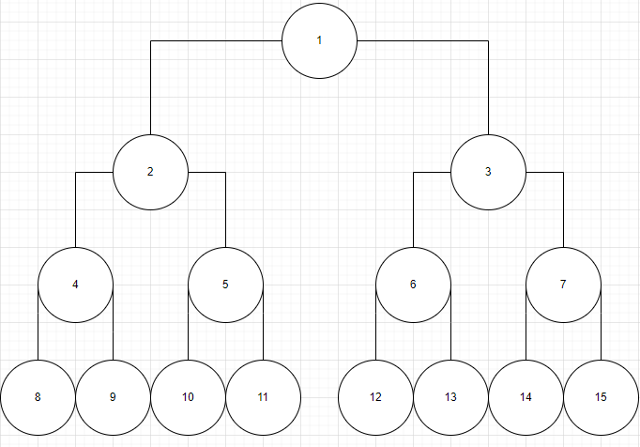

(b). Suppose the goal state is 11. List the order in which nodes will be visited for breadth-first search, depth-limited search with limit 3, and iterative deepening depth-first search.

Breadth-first search: 1 → 2 → 3 → 4 → 5 → 6 → 7 → 8 → 9 → 10 → 11

Depth-limited search: 1 → 2 → 4 → 8 → 9 → 5 → 10 → 11

Iterative deepening depth-first search:  
1

1 → 2 → 3

1 → 2 → 4 → 5 → 3 → 6 → 7

1 → 2 → 4 → 8 → 9 → 5 → 10 → 11

**Problem 3:** (Provide derivations of your answer, that is, draw the search tree, and write down the list of visited nodes in order and the corresponding frontier nodes). Execute **Tree Search** through this graph (i.e. do not remember visited nodes). S is the start node, and G is the goal node. Step costs are given next to each arc. Heuristic function values are given in the table on the right. The successors of each node are indicated by the arrows out of that node. Use the alphabetical order as tie-breakers, i.e. if nodes A, B, and C are available to expand, expand A before B, B before C. For each search strategy below, show the order in which nodes are expanded, ending with the goal node that is found. Show the solution path from start to goal, and give the cost of the solution path that is found.

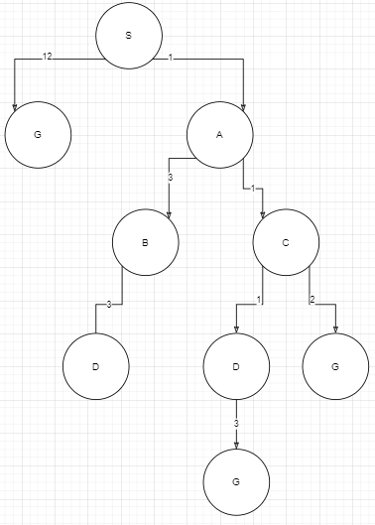

**3.a depth-first search**

Order of node expansion: S G

Path found: S G

Cost of path found: 12

**3.b uniform-cost search**

Order of node expansion: S A C D B G

Path found: S A C G

Cost of path found: 4

**3.c greedy search with** ℎ(𝑛)

Order of node expansion: S G

Path found: S G

Cost of path found: 12

**3.d iterative deepening depth-first search**

Order of node expansion: S G

Path found: S G

Cost of path found: 12

**3.e A* search, and the heuristic function is** ℎ(𝑛)

Order of node expansion: S A C G

Path found: S A C G

Cost of path found: 4

**Problem 4:** (Provide derivations of your answer, that is, draw the search tree, and write down the list of visited nodes in order and the corresponding frontier nodes). Execute Tree Search through this graph. Step costs are given next to each arc. Heuristic values are given next to each node (as ℎ = 𝑥). The successors of each node are indicated by the arrows out of that node. Child nodes are returned from left to right with an alphabetical and numerical order, i.e., children of S are (A, B), children of A are (A, G1, G2), and children of B are (A,B), in that order.

**Note: G1 and G2 are different nodes, but they are both goal nodes.**

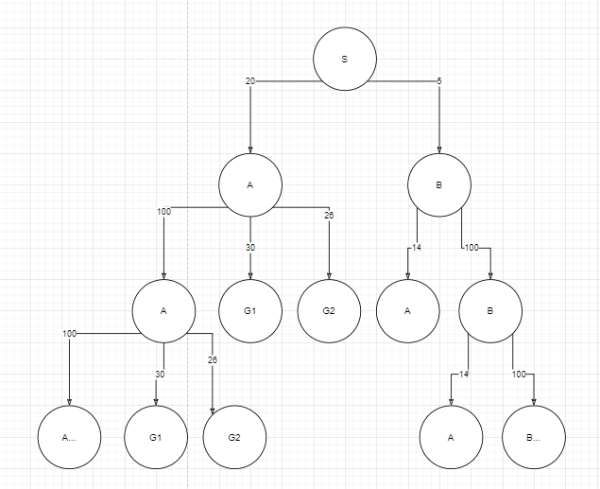

**4.1** Execute greedy tree search, find the following:

a. Order of node expansion: S B B B B…

b. Path found: None

c. Cost of path found: None

**4.2** Execute uniform-cost tree search, find the following:

a. Order of node expansion: S B A G2

b. Path found: S A G2

c. Cost of path found: 46